Chapter Five: Summary, Conclusion and Recommendations

Summary
This project addressed the gap in personalised AI-supported study planning for undergraduate students. To do this, StudyPilot AI was built as a mobile-first web application combining a Next.js client, a Django REST Framework backend, a PostgreSQL database and a trained adherence prediction model. The system collects each learner's available study hours, course difficulty values and behavioural signals, then produces an adherence-adjusted weekly timetable, recommends study strategies through a rule-based engine with heuristic confidence, and tracks adherence through a session log that feeds back into future plans. An adherence prediction model trained on a canonical schema derived from the Open University Learning Analytics Dataset surfaces real-time forecasts in the user interface.
A limitation of the system is the absence of a plan-first workflow gate. Users can log sessions, run the predictor and request recommendations before any study plan exists, which the System Usability Scale evaluation identified as an onboarding deficit. The mean SUS score across eleven participants was 61.82, placing the system in the Grade C usability band.

Conclusion
In conclusion, the developed system meets the aim of providing AI-supported personalised study planning to undergraduate students. By integrating rule-based reasoning, a trained machine learning model and a clean mobile-first interface, StudyPilot AI offers a working platform that delivers measurably better adherence forecasts than a non-intelligent baseline, reducing Mean Absolute Error from 0.3122 to 0.0291 on the held-out test set, and exposes the planning, recommendation and tracking modules through a single integrated workspace.

Recommendation
While the current iteration of StudyPilot AI is functional, the following improvements would extend its potential:
- Plan-first workflow gate: requiring at least one active study plan before the log-session, predictor and recommendation modules become reachable would address the onboarding deficit identified by the SUS evaluation.
- Course autocomplete: replacing the free-text course-name input with a dropdown sourced from the active plan would eliminate the silent name-mismatch errors that currently break the adherence-factor lookup.
- Supervised strategy classifier: once sufficient in-app strategy outcome data has been collected, training a supervised classifier would replace the current rule engine with a learned recommendation model.
- Cloud deployment: hosting the system in a production environment would allow future evaluations and demonstrations to reach a broader participant pool and would let real learner-usage data accumulate for domain adaptation.
- Calendar integration and reminders: connecting the planner output to the learner's existing calendar and sending timely reminders for scheduled study sessions would remove the need for the learner to consult the planner on a separate screen.
By addressing these recommendations, StudyPilot AI can become a more polished and broadly useful tool for supporting personalised study planning across higher education.

Appendices
The appendices contain the design diagrams that supported the implementation and the principal source listings for the artificial intelligence components of the system.

I. Diagrams
The diagrams included in this appendix complement the UML diagrams presented in Chapter Three. Rather than duplicating those design-time diagrams, the figures here document the implemented system from three additional perspectives: the deployed component architecture, the persistence layer schema and the machine learning pipeline that supports the adherence prediction model.

System Architecture Diagram
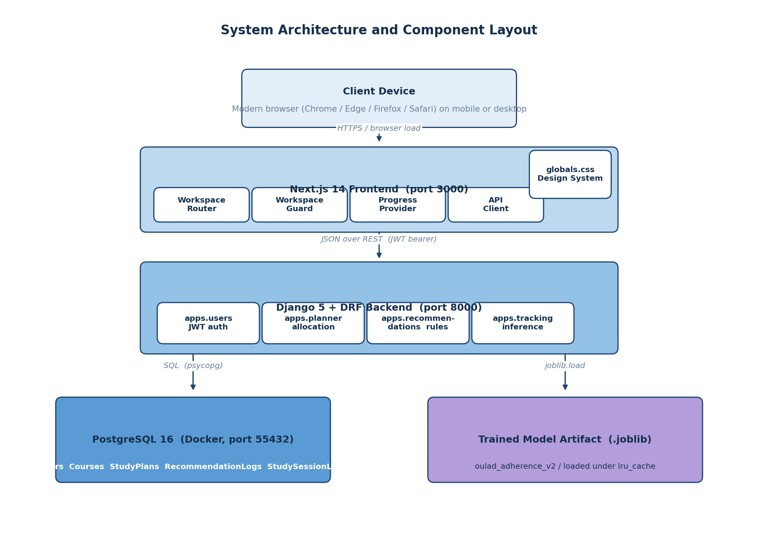
Figure A.1: System architecture and component layout, showing the layered deployment of the Next.js client, the Django REST backend with its four apps, the PostgreSQL database and the trained adherence model artifact.

Entity Relationship Diagram
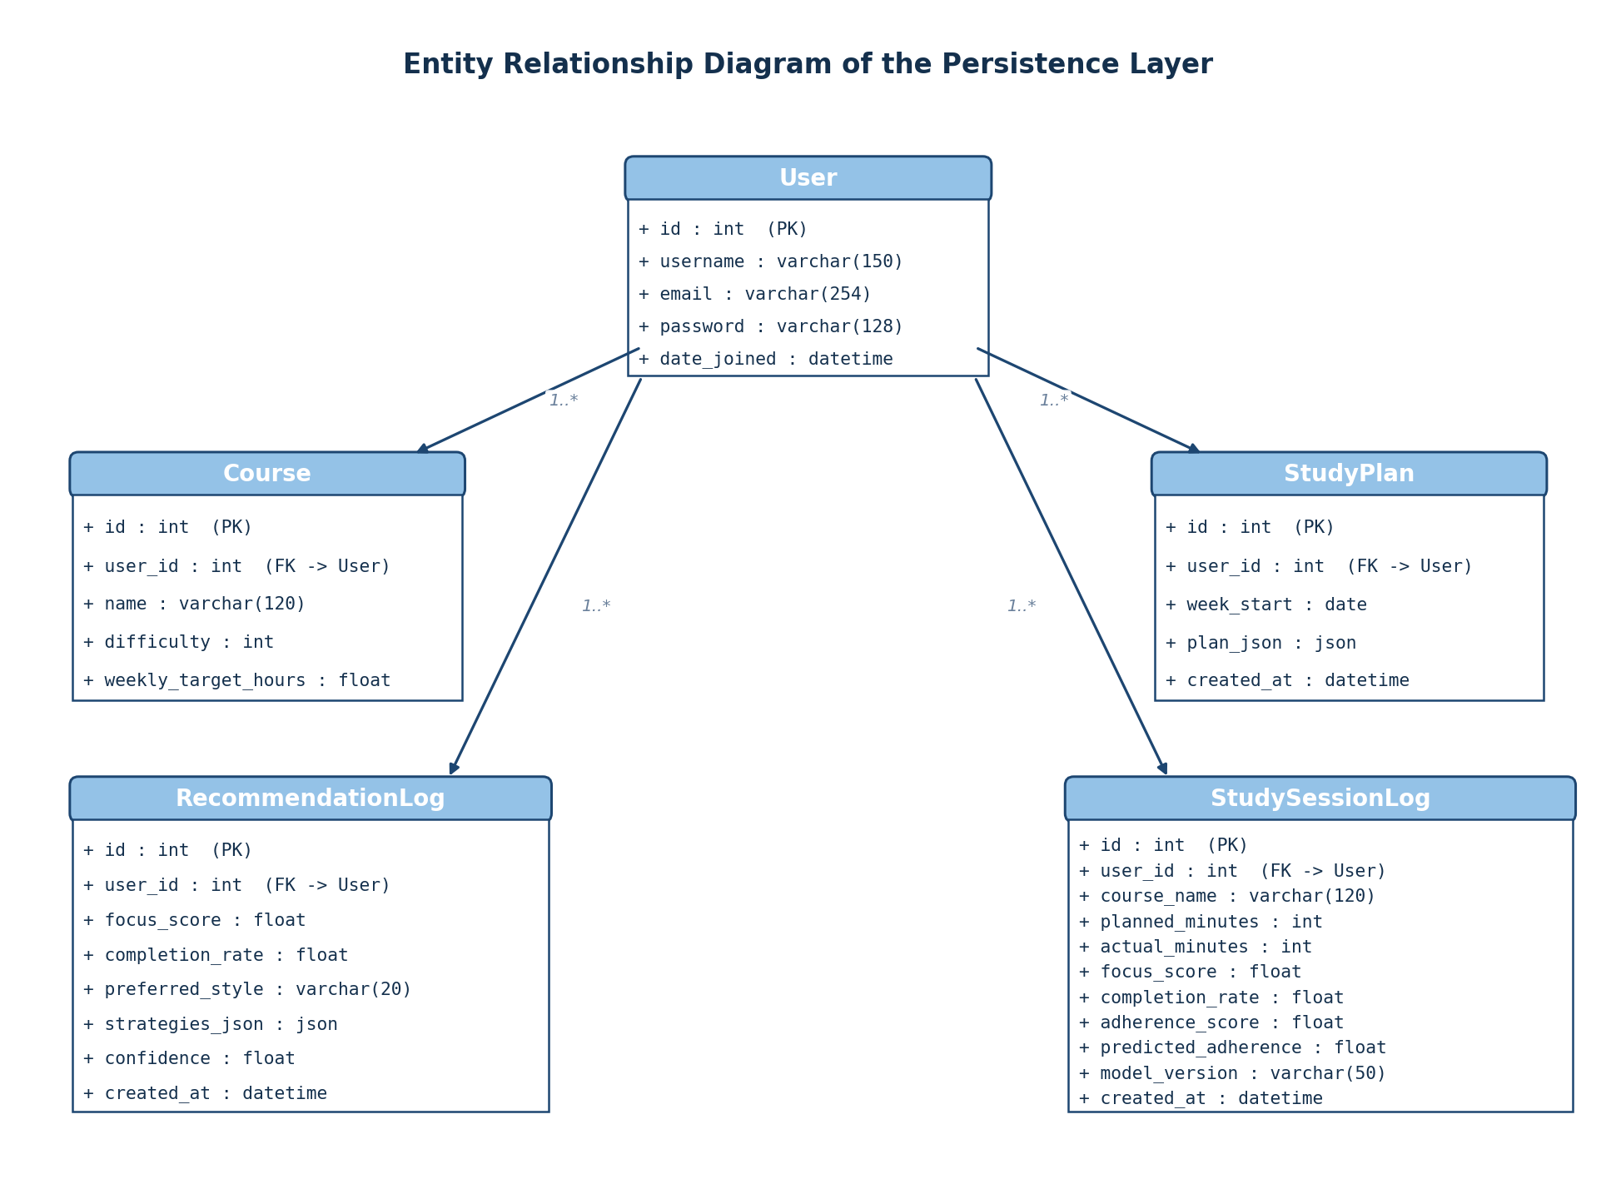
Figure A.2: Entity relationship diagram of the persistence layer, showing the User entity at the centre and the four related tables (Course, StudyPlan, RecommendationLog and StudySessionLog) each linked through a foreign key on the user identifier.

Machine Learning Pipeline Diagram
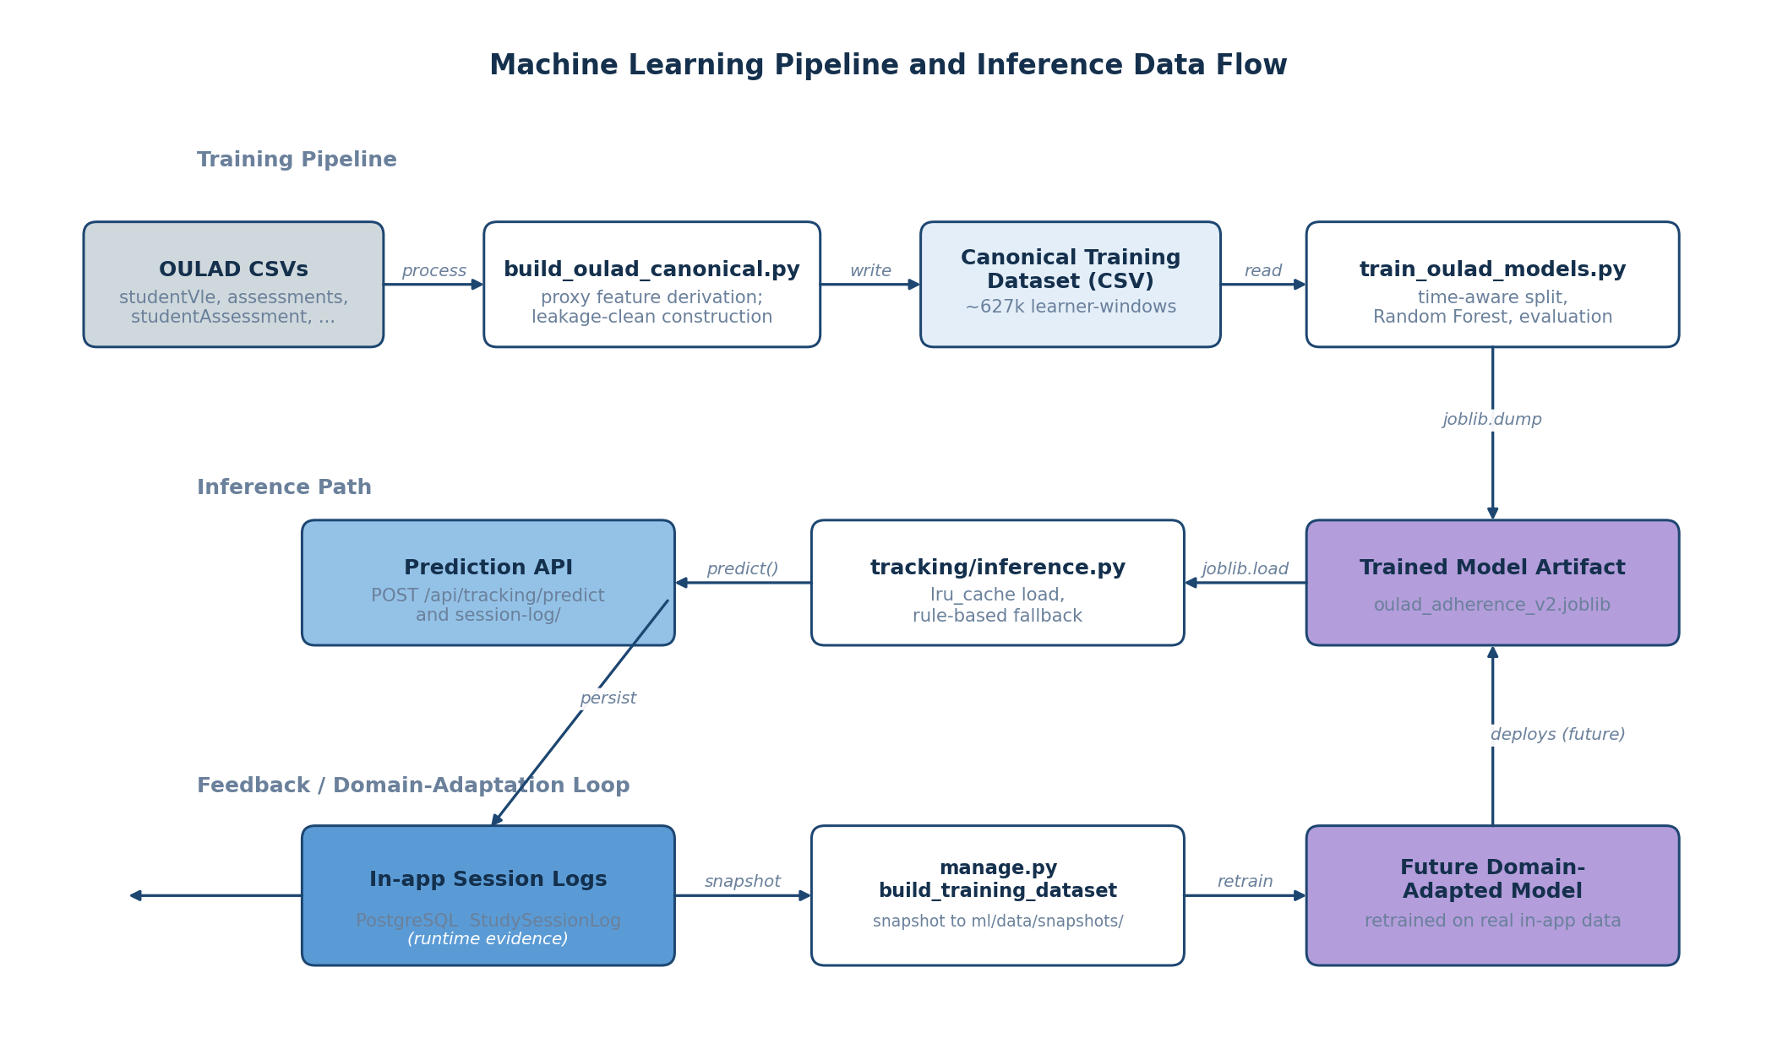
Figure A.3: Machine learning pipeline and inference data flow, showing the training pipeline that builds the canonical dataset from OULAD and trains the Random Forest model, the inference path through the tracking module, and the feedback loop that supports future domain adaptation from in-app data.

II. Program Source Codes
The complete source code of the project is available at the GitHub repository https://github.com/kene-obiekwe/cs_fyp_2026. The principal source listings for the artificial intelligence components of the system are reproduced in full in the subsections that follow.

Pilot Demo Seeder
The pilot demo seeder is a Django management command that creates five deterministic pilot users each with a distinct adherence profile, used to populate the demonstration environment for the screenshot captures in Chapter Four. The source listing of backend/apps/users/management/commands/seed_pilot_data.py is reproduced below.
"""
Seed deterministic pilot demo data for Chapter 4 screenshots and end-to-end demos.

Creates five pilot users with distinct adherence/focus profiles, three courses each,
one study plan, a handful of recommendation logs, and roughly 18 session logs
spread over the last 28 days. Timestamps are backdated so the planner's 30-day
adherence-factor lookup and the progress dashboard's history paging both show
meaningful content immediately.

This is demo data for system validation, NOT real pilot user feedback. Real pilot
feedback is collected separately and remains future work.

Re-running the command is safe: it uses get_or_create for users and courses, and
clears prior plans/recommendations/sessions for the pilot accounts before
re-seeding so the data stays deterministic across runs.

Usage (from backend/):

python manage.py seed_pilot_data
python manage.py seed_pilot_data --reset
"""

from __future__ import annotations

import random
from dataclasses import dataclass
from datetime import timedelta
from typing import Iterable

from django.contrib.auth.models import User
from django.core.management.base import BaseCommand
from django.db import transaction
from django.utils import timezone

from apps.planner.models import Course, StudyPlan
from apps.planner.services import generate_plan
from apps.recommendations.models import RecommendationLog
from apps.recommendations.services import get_recommendations
from apps.tracking.inference import build_feature_payload, predict_adherence
from apps.tracking.models import StudySessionLog

@dataclass(frozen=True)
class PilotProfile:
username: str
full_label: str
preferred_style: str
adherence_mean: float # baseline ratio of actual / planned minutes
adherence_jitter: float # +- noise applied per session
focus_mean: float
completion_mean: float
sessions_per_week: int # roughly how many sessions to seed per 7-day window

PILOTS: tuple[PilotProfile, ...] = (
PilotProfile(
username="pilot_consistent",
full_label="Consistent high adherer (visual learner)",
preferred_style="visual",
adherence_mean=0.92,
adherence_jitter=0.08,
focus_mean=0.82,
completion_mean=0.84,
sessions_per_week=5,
),
PilotProfile(
username="pilot_struggling",
full_label="Struggling learner (mixed approach)",
preferred_style="mixed",
adherence_mean=0.45,
adherence_jitter=0.15,
focus_mean=0.40,
completion_mean=0.42,
sessions_per_week=3,
),
PilotProfile(
username="pilot_improving",
full_label="Improving practice-oriented learner",
preferred_style="practice",
adherence_mean=0.70,
adherence_jitter=0.12,
focus_mean=0.65,
completion_mean=0.68,
sessions_per_week=4,
),
PilotProfile(
username="pilot_declining",
full_label="Declining reading-oriented learner",
preferred_style="reading",
adherence_mean=0.60,
adherence_jitter=0.18,
focus_mean=0.55,
completion_mean=0.55,
sessions_per_week=4,
),
PilotProfile(
username="pilot_average",
full_label="Average mixed learner",
preferred_style="mixed",
adherence_mean=0.75,
adherence_jitter=0.10,
focus_mean=0.70,
completion_mean=0.72,
sessions_per_week=4,
),
)

PILOT_PASSWORD = "Pilot12345!" # documented in docs/pilot-demo-guide.md

COURSE_CATALOG: tuple[tuple[str, int, float], ...] = (
# (name, difficulty 1-5, weekly_target_hours)
("CSC 401 Algorithms", 4, 6.0),
("MTH 401 Numerical Methods", 5, 5.0),
("STA 401 Probability Models", 3, 4.0),
("PHY 301 Modern Physics", 3, 3.0),
("ENG 401 Software Engineering", 4, 5.0),
)

# Each pilot picks three courses by index (deterministic per pilot)
PILOT_COURSE_INDICES = {
"pilot_consistent": (0, 1, 4),
"pilot_struggling": (0, 2, 3),
"pilot_improving": (1, 2, 4),
"pilot_declining": (0, 3, 4),
"pilot_average": (0, 1, 2),
}

SEED_DAYS_WINDOW = 28

def _clamp(value: float, lo: float = 0.0, hi: float = 1.0) -> float:
return max(lo, min(hi, value))

def _bounded_normal(rng: random.Random, mean: float, jitter: float) -> float:
return _clamp(rng.gauss(mean, jitter))

class Command(BaseCommand):
help = "Seed deterministic pilot demo data for Chapter 4 screenshots and end-to-end demos."

def add_arguments(self, parser) -> None:
parser.add_argument(
"--reset",
action="store_true",
help="Delete prior pilot users entirely before reseeding (default keeps users, clears their data).",
)

@transaction.atomic
def handle(self, *args, **options) -> None:
reset = bool(options.get("reset"))
rng = random.Random(20260529)

now = timezone.now()
seed_start = now - timedelta(days=SEED_DAYS_WINDOW)

if reset:
deleted, _ = User.objects.filter(username__in=[p.username for p in PILOTS]).delete()
self.stdout.write(self.style.WARNING(f"Reset: deleted {deleted} pilot user records and cascaded data."))

for profile in PILOTS:
user = self._upsert_user(profile)
self._clear_existing_data(user)
courses = self._upsert_courses(user, profile)
plan = self._seed_plan(user, courses, now)
self._seed_recommendations(user, profile, plan, seed_start, now)
self._seed_sessions(user, profile, courses, seed_start, now, rng)
self.stdout.write(self.style.SUCCESS(f"Seeded pilot: {user.username} ({profile.full_label})"))

self.stdout.write(self.style.SUCCESS(""))
self.stdout.write(self.style.SUCCESS(f"Done. {len(PILOTS)} pilot users seeded. Password for all: {PILOT_PASSWORD}"))
self.stdout.write(self.style.SUCCESS("See docs/pilot-demo-guide.md for the screenshot checklist."))

# -- helpers ----------------------------------------------------------------

def _upsert_user(self, profile: PilotProfile) -> User:
user, created = User.objects.get_or_create(
username=profile.username,
defaults={"email": f"{profile.username}@studyplanner.local"},
)
user.set_password(PILOT_PASSWORD)
user.email = f"{profile.username}@studyplanner.local"
user.save()
if created:
self.stdout.write(f" + created user {profile.username}")
return user

def _clear_existing_data(self, user: User) -> None:
StudySessionLog.objects.filter(user=user).delete()
RecommendationLog.objects.filter(user=user).delete()
StudyPlan.objects.filter(user=user).delete()
# Courses are kept (re-upserted) to preserve external referential pointers

def _upsert_courses(self, user: User, profile: PilotProfile) -> list[Course]:
indices = PILOT_COURSE_INDICES[profile.username]
result: list[Course] = []
for idx in indices:
name, difficulty, weekly = COURSE_CATALOG[idx]
course, _ = Course.objects.update_or_create(
user=user,
name=name,
defaults={"difficulty": difficulty, "weekly_target_hours": weekly},
)
result.append(course)
return result

def _seed_plan(self, user: User, courses: list[Course], now) -> StudyPlan:
course_payload = [{"name": c.name, "difficulty": c.difficulty} for c in courses]
total_hours = sum(c.weekly_target_hours for c in courses)
allocations = generate_plan(total_hours, course_payload)
week_start = (now - timedelta(days=now.weekday())).date()
plan = StudyPlan.objects.create(
user=user,
week_start=week_start,
plan_json={
"total_available_hours": total_hours,
"courses": course_payload,
"allocations": allocations,
"adherence_adjustments": {},
},
)
# Backdate the plan to the start of the seed window so the planner history
# shows it among older entries rather than always as "today".
StudyPlan.objects.filter(pk=plan.pk).update(created_at=now - timedelta(days=SEED_DAYS_WINDOW // 2))
return plan

def _seed_recommendations(
self,
user: User,
profile: PilotProfile,
plan: StudyPlan,
seed_start,
now,
) -> None:
# Three recommendation events: at start of window, midpoint, near present.
markers = [seed_start, seed_start + timedelta(days=SEED_DAYS_WINDOW // 2), now - timedelta(days=1)]
for marker in markers:
strategies, confidence = get_recommendations(
focus_score=profile.focus_mean,
completion_rate=profile.completion_mean,
preferred_style=profile.preferred_style,
)
log = RecommendationLog.objects.create(
user=user,
focus_score=profile.focus_mean,
completion_rate=profile.completion_mean,
preferred_style=profile.preferred_style,
strategies_json=strategies,
confidence=confidence,
)
RecommendationLog.objects.filter(pk=log.pk).update(created_at=marker)

def _seed_sessions(
self,
user: User,
profile: PilotProfile,
courses: list[Course],
seed_start,
now,
rng: random.Random,
) -> None:
total_sessions = max(1, int(profile.sessions_per_week * SEED_DAYS_WINDOW / 7))
session_gap_seconds = int((now - seed_start).total_seconds() / total_sessions)

course_cycle: Iterable[Course] = _round_robin(courses)
recent_dates: list = [] # rolling window for sessions_last_7_days
for i, course in zip(range(total_sessions), course_cycle):
planned_minutes = rng.choice([60, 75, 90, 105, 120])
adherence_ratio = _bounded_normal(rng, profile.adherence_mean, profile.adherence_jitter)
actual_minutes = max(0, int(round(planned_minutes * adherence_ratio)))
adherence_score = round(min(1.0, actual_minutes / max(1, planned_minutes)), 2)
focus_score = round(_bounded_normal(rng, profile.focus_mean, profile.adherence_jitter / 2), 2)
completion_rate = round(_bounded_normal(rng, profile.completion_mean, profile.adherence_jitter / 2), 2)

target_ts = seed_start + timedelta(seconds=session_gap_seconds * i)

# Compute the same rolling feature inputs that SessionLogView would
# compute at log-time, so predicted_adherence reflects the model on
# realistic state rather than zeros.
cutoff = target_ts - timedelta(days=7)
recent_dates = [d for d in recent_dates if d >= cutoff]
recent_dates.append(target_ts)
sessions_last_7_days = len(recent_dates)
created_at_offset_days = (target_ts - seed_start).days
consistency_score = min(1.0, sessions_last_7_days / 7.0)

feature_payload = build_feature_payload(
planned_minutes=planned_minutes,
completion_rate=completion_rate,
sessions_last_7_days=sessions_last_7_days,
focus_score=focus_score,
consistency_score=consistency_score,
created_at_offset_days=created_at_offset_days,
)
predicted_adherence, model_version = predict_adherence(feature_payload)

log = StudySessionLog.objects.create(
user=user,
course_name=course.name,
planned_minutes=planned_minutes,
actual_minutes=actual_minutes,
focus_score=focus_score,
completion_rate=completion_rate,
adherence_score=adherence_score,
predicted_adherence=predicted_adherence,
model_version=model_version,
)
StudySessionLog.objects.filter(pk=log.pk).update(created_at=target_ts)

def _round_robin(items: list):
while True:
for item in items:
yield item

Adherence Model Training Script
The adherence model training script trains the Random Forest regression model on the canonical training dataset, performs the time-aware split, conducts a hyperparameter search, evaluates the result on the held-out test set, and saves the model artifact and evaluation plots. The source listing of backend/ml/train_oulad_models.py is reproduced below.
import argparse
import json
from pathlib import Path

import joblib
import numpy as np
import pandas as pd
import matplotlib.pyplot as plt
from sklearn.impute import SimpleImputer
from sklearn.metrics import mean_absolute_error, mean_squared_error, r2_score
from sklearn.model_selection import train_test_split
from sklearn.pipeline import Pipeline
from sklearn.ensemble import RandomForestRegressor

FEATURE_COLUMNS = [
"planned_minutes",
"completion_rate",
"sessions_last_7_days",
"focus_score",
"help_seeking_rate",
"consistency_score",
"avg_quiz_score_recent",
"created_at",
]

QUALITY_COLUMNS = list(dict.fromkeys(FEATURE_COLUMNS + ["actual_minutes"]))

def parse_args() -> argparse.Namespace:
parser = argparse.ArgumentParser(description="Train adherence model on OULAD canonical dataset.")
parser.add_argument(
"--data",
default="backend/ml/data/oulad/training_dataset.csv",
help="Path to canonical OULAD training CSV.",
)
parser.add_argument(
"--output-dir",
default="backend/ml/models",
help="Directory to write model artifacts.",
)
parser.add_argument(
"--report-dir",
default="backend/ml/reports",
help="Directory to write training reports.",
)
parser.add_argument(
"--test-size",
type=float,
default=0.2,
help="Test split size (default: 0.2).",
)
parser.add_argument(
"--val-size",
type=float,
default=0.1,
help="Validation split size (default: 0.1).",
)
parser.add_argument(
"--split",
choices=["random", "time"],
default="time",
help="Split strategy: random or time-based (default: time).",
)
parser.add_argument(
"--limit",
type=int,
default=200000,
help="Optional row limit for faster runs (0 means all rows).",
)
parser.add_argument(
"--n-estimators",
type=int,
default=200,
help="Number of trees for RandomForestRegressor (default: 200).",
)
return parser.parse_args()

def build_splits(df: pd.DataFrame, test_size: float, val_size: float, split: str):
if test_size <= 0 or val_size < 0:
raise ValueError("test_size must be > 0 and val_size must be >= 0")
if test_size + val_size >= 1:
raise ValueError("test_size + val_size must be < 1")

if split == "time":
df = df.sort_values("created_at")
n = len(df)
n_train = int(n * (1 - test_size - val_size))
n_val = int(n * val_size)
train_df = df.iloc[:n_train]
val_df = df.iloc[n_train : n_train + n_val]
test_df = df.iloc[n_train + n_val :]
return train_df, val_df, test_df

train_val_df, test_df = train_test_split(df, test_size=test_size, random_state=42)
relative_val = val_size / (1 - test_size)
train_df, val_df = train_test_split(train_val_df, test_size=relative_val, random_state=42)
return train_df, val_df, test_df

def data_quality_checks(df: pd.DataFrame) -> dict:
checks = {
"row_count": int(len(df)),
"duplicate_rows": int(df.duplicated().sum()),
"missing_rate": df[QUALITY_COLUMNS + ["adherence_score"]].isna().mean().round(4).to_dict(),
"adherence_out_of_bounds": int(((df["adherence_score"] < 0) | (df["adherence_score"] > 1)).sum()),
"completion_rate_out_of_bounds": int(((df["completion_rate"] < 0) | (df["completion_rate"] > 1)).sum()),
"planned_minutes_non_positive": int((df["planned_minutes"] <= 0).sum()),
"actual_minutes_negative": int((df["actual_minutes"] < 0).sum()),
}
return checks

def score_metrics(y_true: np.ndarray, y_pred: np.ndarray) -> dict:
return {
"mae": float(mean_absolute_error(y_true, y_pred)),
"rmse": float(np.sqrt(mean_squared_error(y_true, y_pred))),
"r2": float(r2_score(y_true, y_pred)),
}

def save_plots(
y_true: np.ndarray,
y_pred: np.ndarray,
baseline_pred: np.ndarray,
feature_importances: dict,
output_dir: Path,
):
output_dir.mkdir(parents=True, exist_ok=True)

sample_size = min(len(y_true), 15000)
if sample_size < len(y_true):
idx = np.random.RandomState(42).choice(len(y_true), size=sample_size, replace=False)
y_true = y_true[idx]
y_pred = y_pred[idx]
baseline_pred = baseline_pred[idx]

plt.figure(figsize=(6, 5))
plt.scatter(y_true, y_pred, alpha=0.25, s=8)
plt.plot([0, 1], [0, 1], color="black", linestyle="--", linewidth=1)
plt.xlabel("True adherence")
plt.ylabel("Predicted adherence")
plt.title("Predicted vs True (Sample)")
scatter_path = output_dir / "predicted_vs_true.png"
plt.tight_layout()
plt.savefig(scatter_path, dpi=160)
plt.close()

residuals = y_true - y_pred
plt.figure(figsize=(6, 4))
plt.hist(residuals, bins=50, color="#4c78a8", alpha=0.85)
plt.xlabel("Residual (true - predicted)")
plt.ylabel("Count")
plt.title("Residual Distribution")
resid_path = output_dir / "residuals_hist.png"
plt.tight_layout()
plt.savefig(resid_path, dpi=160)
plt.close()

baseline_metrics = score_metrics(y_true, baseline_pred)
model_metrics = score_metrics(y_true, y_pred)
labels = ["MAE", "RMSE", "R2"]
baseline_vals = [baseline_metrics["mae"], baseline_metrics["rmse"], baseline_metrics["r2"]]
model_vals = [model_metrics["mae"], model_metrics["rmse"], model_metrics["r2"]]

x = np.arange(len(labels))
width = 0.35
plt.figure(figsize=(6, 4))
plt.bar(x - width / 2, baseline_vals, width, label="Baseline")
plt.bar(x + width / 2, model_vals, width, label="Model")
plt.xticks(x, labels)
plt.title("Baseline vs Model Metrics")
plt.legend()
metrics_path = output_dir / "baseline_vs_model.png"
plt.tight_layout()
plt.savefig(metrics_path, dpi=160)
plt.close()

if feature_importances:
names = list(feature_importances.keys())
values = list(feature_importances.values())
order = np.argsort(values)
plt.figure(figsize=(7, 5))
plt.barh([names[i] for i in order], [values[i] for i in order])
plt.xlabel("Importance")
plt.title("Feature Importance")
feat_path = output_dir / "feature_importance.png"
plt.tight_layout()
plt.savefig(feat_path, dpi=160)
plt.close()

return {
"predicted_vs_true": str(scatter_path),
"residuals_hist": str(resid_path),
"baseline_vs_model": str(metrics_path),
"feature_importance": str(output_dir / "feature_importance.png"),
}

def main() -> None:
args = parse_args()
data_path = Path(args.data)
if not data_path.exists():
raise SystemExit(f"Training data not found: {data_path}")

df = pd.read_csv(data_path)
if args.limit and args.limit > 0 and len(df) > args.limit:
if args.split == "time":
df = df.sort_values("created_at").tail(args.limit)
else:
df = df.sample(n=args.limit, random_state=42)

quality = data_quality_checks(df)

train_df, val_df, test_df = build_splits(df, args.test_size, args.val_size, args.split)

X_train = train_df[FEATURE_COLUMNS]
y_train = train_df["adherence_score"]
X_val = val_df[FEATURE_COLUMNS]
y_val = val_df["adherence_score"]
X_test = test_df[FEATURE_COLUMNS]
y_test = test_df["adherence_score"]

baseline_pred = np.full_like(y_test, y_train.mean(), dtype=float)
baseline_metrics = score_metrics(y_test, baseline_pred)

param_grid = [
{"n_estimators": args.n_estimators, "max_depth": None, "min_samples_leaf": 1},
{"n_estimators": args.n_estimators, "max_depth": 12, "min_samples_leaf": 2},
{"n_estimators": args.n_estimators, "max_depth": 20, "min_samples_leaf": 5},
]

best = {"rmse": float("inf"), "params": None, "model": None}
for params in param_grid:
model = Pipeline(
steps=[
("imputer", SimpleImputer(strategy="median")),
(
"regressor",
RandomForestRegressor(
n_estimators=params["n_estimators"],
max_depth=params["max_depth"],
min_samples_leaf=params["min_samples_leaf"],
random_state=42,
n_jobs=-1,
),
),
]
)
model.fit(X_train, y_train)
val_pred = model.predict(X_val)
rmse = float(np.sqrt(mean_squared_error(y_val, val_pred)))
if rmse < best["rmse"]:
best = {"rmse": rmse, "params": params, "model": model}

best_params = best["params"]
final_model = best["model"]

# Refit on train + val for final evaluation
X_train_full = pd.concat([X_train, X_val], axis=0)
y_train_full = pd.concat([y_train, y_val], axis=0)
final_model.fit(X_train_full, y_train_full)

preds = final_model.predict(X_test)
model_metrics = score_metrics(y_test, preds)

output_dir = Path(args.output_dir)
output_dir.mkdir(parents=True, exist_ok=True)
model_path = output_dir / "oulad_adherence_model.joblib"
joblib.dump(final_model, model_path)

report_dir = Path(args.report_dir)
report_dir.mkdir(parents=True, exist_ok=True)
report_path = report_dir / "oulad_training_report.json"

plot_dir = report_dir / "oulad_plots"
feature_importances = {}
regressor = final_model.named_steps.get("regressor")
if hasattr(regressor, "feature_importances_"):
feature_importances = {
name: float(val)
for name, val in zip(FEATURE_COLUMNS, regressor.feature_importances_)
}
plot_paths = save_plots(
y_test.to_numpy(),
preds,
baseline_pred,
feature_importances,
plot_dir,
)

report = {
"data_path": str(data_path),
"row_count": int(len(df)),
"feature_columns": FEATURE_COLUMNS,
"data_quality": quality,
"feature_importance": feature_importances,
"split": args.split,
"val_size": args.val_size,
"test_size": args.test_size,
"limit": args.limit,
"best_params": best_params,
"baseline_metrics": baseline_metrics,
"model_metrics": model_metrics,
"model_path": str(model_path),
"plots": plot_paths,
}

report_path.write_text(json.dumps(report, indent=2), encoding="utf-8")

print("Training complete")
print(json.dumps(report, indent=2))

if __name__ == "__main__":
main()

OULAD Canonical Schema Builder
The canonical schema builder adapts the Open University Learning Analytics Dataset into the project canonical training schema using the proxy definitions documented in Chapter Four. The version reproduced here incorporates the leakage-clean construction of the completion_rate feature described in Section 4.3.4. The source listing of backend/ml/build_oulad_canonical.py is reproduced below.
import argparse
import json
from datetime import datetime
from pathlib import Path

import numpy as np
import pandas as pd

CANONICAL_COLUMNS = [
"user_id",
"planned_minutes",
"actual_minutes",
"completion_rate",
"sessions_last_7_days",
"focus_score",
"help_seeking_rate",
"consistency_score",
"avg_quiz_score_recent",
"created_at",
"adherence_score",
"strategy_label",
]

def parse_args() -> argparse.Namespace:
parser = argparse.ArgumentParser(
description="Build a canonical training dataset from OULAD using proxy features."
)
parser.add_argument(
"--input-dir",
default="dataset",
help="Directory containing OULAD CSV files.",
)
parser.add_argument(
"--output-dir",
default="backend/ml/data/oulad",
help="Directory to write training_dataset.csv and metadata.json.",
)
parser.add_argument(
"--window-size",
type=int,
default=7,
help="Window size in days for aggregation (default: 7).",
)
parser.add_argument(
"--clicks-per-minute",
type=float,
default=5.0,
help="Scaling factor to convert clicks to estimated minutes (default: 5).",
)
parser.add_argument(
"--chunksize",
type=int,
default=500000,
help="CSV chunk size for studentVle processing (default: 500000).",
)
return parser.parse_args()

def load_vle_map(input_dir: Path) -> pd.DataFrame:
vle_path = input_dir / "vle.csv"
vle_df = pd.read_csv(vle_path)
vle_df["activity_type"] = vle_df["activity_type"].fillna("")
help_keywords = (
"forum",
"wiki",
"collab",
"oucontent",
"resource",
"page",
"subpage",
)
vle_df["is_help"] = vle_df["activity_type"].str.contains(
"|".join(help_keywords), case=False, regex=True
)
return vle_df[["id_site", "is_help"]], list(help_keywords)

def build_activity_windows(
input_dir: Path,
vle_map: pd.DataFrame,
window_size: int,
chunksize: int,
) -> pd.DataFrame:
student_vle_path = input_dir / "studentVle.csv"

dtype = {
"code_module": "category",
"code_presentation": "category",
"id_student": "int32",
"id_site": "int32",
"date": "int16",
"sum_click": "int32",
}

daily_parts: list[pd.DataFrame] = []
for chunk in pd.read_csv(student_vle_path, dtype=dtype, chunksize=chunksize):
chunk = chunk.merge(vle_map, how="left", on="id_site")
chunk["is_help"] = chunk["is_help"].fillna(False)
chunk["window_start"] = (chunk["date"] // window_size) * window_size
chunk["help_clicks"] = np.where(chunk["is_help"], chunk["sum_click"], 0)

daily = (
chunk.groupby(
[
"id_student",
"code_module",
"code_presentation",
"window_start",
"date",
],
as_index=False,
observed=True,
)
.agg(total_clicks=("sum_click", "sum"), help_clicks=("help_clicks", "sum"))
)
daily_parts.append(daily)

daily_df = pd.concat(daily_parts, ignore_index=True)
daily_df = (
daily_df.groupby(
[
"id_student",
"code_module",
"code_presentation",
"window_start",
"date",
],
as_index=False,
observed=True,
)
.agg(total_clicks=("total_clicks", "sum"), help_clicks=("help_clicks", "sum"))
)

window_df = (
daily_df.groupby(
["id_student", "code_module", "code_presentation", "window_start"],
as_index=False,
observed=True,
)
.agg(
total_clicks=("total_clicks", "sum"),
help_clicks=("help_clicks", "sum"),
active_days=("date", "nunique"),
)
)
window_df["avg_clicks_per_active_day"] = np.where(
window_df["active_days"] > 0,
window_df["total_clicks"] / window_df["active_days"],
0,
)
return window_df

def build_assessment_windows(input_dir: Path, window_size: int) -> pd.DataFrame:
assessments_path = input_dir / "assessments.csv"
student_assess_path = input_dir / "studentAssessment.csv"

assessments = pd.read_csv(assessments_path)
student_assess = pd.read_csv(student_assess_path)

merged = student_assess.merge(assessments, how="left", on="id_assessment")
merged["assessment_date"] = np.where(
merged["date_submitted"] >= 0,
merged["date_submitted"],
merged["date"],
)
merged["window_start"] = (merged["assessment_date"] // window_size) * window_size

window_scores = (
merged.groupby(
["id_student", "code_module", "code_presentation", "window_start"],
as_index=False,
observed=True,
)
.agg(mean_score=("score", "mean"))
)
return window_scores

def clip_01(values):
if isinstance(values, pd.Series):
return values.clip(lower=0, upper=1)
return np.clip(values, 0, 1)

def main() -> None:
args = parse_args()
input_dir = Path(args.input_dir)
output_dir = Path(args.output_dir)
output_dir.mkdir(parents=True, exist_ok=True)

vle_map, help_keywords = load_vle_map(input_dir)
activity_windows = build_activity_windows(
input_dir,
vle_map,
window_size=args.window_size,
chunksize=args.chunksize,
)
assessment_windows = build_assessment_windows(input_dir, window_size=args.window_size)

window_df = activity_windows.merge(
assessment_windows,
how="left",
on=["id_student", "code_module", "code_presentation", "window_start"],
)

expected_clicks = (
window_df.groupby(
["code_module", "code_presentation", "window_start"],
as_index=False,
observed=True,
)
.agg(expected_clicks=("total_clicks", "median"))
)
window_df = window_df.merge(
expected_clicks,
how="left",
on=["code_module", "code_presentation", "window_start"],
)

clicks_per_minute = max(args.clicks_per_minute, 1e-6)
window_df["actual_minutes"] = window_df["total_clicks"] / clicks_per_minute
window_df["planned_minutes"] = window_df["expected_clicks"] / clicks_per_minute

engagement_ratio = np.where(
window_df["expected_clicks"] > 0,
window_df["total_clicks"] / window_df["expected_clicks"],
0,
)

# completion_rate is derived ONLY from assessment scores. Falling back to
# engagement_ratio (as in an earlier version) made completion_rate identical
# to adherence_score for the ~78% of rows without assessment data, producing
# severe target leakage. Leaving NaN here lets the model's median imputer
# handle missingness while keeping completion_rate and adherence_score
# derived from independent signals.
window_df["completion_rate"] = window_df["mean_score"] / 100.0

p90 = np.percentile(window_df["avg_clicks_per_active_day"], 90) if len(window_df) else 1.0
p90 = p90 if p90 > 0 else 1.0
window_df["focus_score"] = clip_01(window_df["avg_clicks_per_active_day"] / p90)

window_df["help_seeking_rate"] = np.where(
window_df["total_clicks"] > 0,
window_df["help_clicks"] / window_df["total_clicks"],
np.nan,
)

window_df["consistency_score"] = clip_01(window_df["active_days"] / args.window_size)
window_df["sessions_last_7_days"] = window_df["active_days"]
window_df["avg_quiz_score_recent"] = window_df["mean_score"] / 100.0
window_df["created_at"] = window_df["window_start"] + (args.window_size - 1)

window_df["adherence_score"] = clip_01(engagement_ratio)
window_df["strategy_label"] = ""

completion_rate_clipped = window_df["completion_rate"].clip(lower=0, upper=1)

output_df = pd.DataFrame(
{
"user_id": window_df["id_student"],
"planned_minutes": window_df["planned_minutes"],
"actual_minutes": window_df["actual_minutes"],
"completion_rate": completion_rate_clipped,
"sessions_last_7_days": window_df["sessions_last_7_days"],
"focus_score": window_df["focus_score"],
"help_seeking_rate": window_df["help_seeking_rate"],
"consistency_score": window_df["consistency_score"],
"avg_quiz_score_recent": window_df["avg_quiz_score_recent"],
"created_at": window_df["created_at"],
"adherence_score": window_df["adherence_score"],
"strategy_label": window_df["strategy_label"],
}
)

output_df = output_df[CANONICAL_COLUMNS]

output_path = output_dir / "training_dataset.csv"
output_df.to_csv(output_path, index=False)

metadata = {
"generated_at": datetime.utcnow().isoformat() + "Z",
"input_dir": str(input_dir),
"output_file": str(output_path),
"row_count": int(len(output_df)),
"window_size_days": args.window_size,
"clicks_per_minute": args.clicks_per_minute,
"help_keywords": help_keywords,
"proxy_definitions": {
"actual_minutes": "total_clicks / clicks_per_minute",
"planned_minutes": "median total_clicks per module/presentation/window / clicks_per_minute",
"completion_rate": "mean assessment score / 100 if assessment data available, else NaN (imputer handles missingness; engagement_ratio fallback was removed to avoid target leakage with adherence_score)",
"focus_score": "avg_clicks_per_active_day scaled by p90",
"help_seeking_rate": "help_clicks / total_clicks using activity_type keywords",
"consistency_score": "active_days / window_size",
"adherence_score": "total_clicks / expected_clicks (clipped)",
"created_at": "window_end_day (relative to presentation start)",
},
"missing_counts": output_df.isna().sum().to_dict(),
"notes": [
"created_at is a relative day index, not a calendar datetime.",
"strategy_label is intentionally blank because OULAD has no strategy labels.",
],
}

metadata_path = output_dir / "metadata.json"
metadata_path.write_text(json.dumps(metadata, indent=2), encoding="utf-8")

print(f"Wrote {len(output_df)} rows to {output_path}")
print(f"Metadata written to {metadata_path}")

if __name__ == "__main__":
main()

